

**SHAHEED MAJOR SANJEEV LATHAR**

**GOVERNMENT COLLEGE JULANA (JIND)**

(Affiliated to C.R.S.University, Jind)

Address: Karsola Road, Julana-126101Ph. 01683275800

Website: gcjulana.ac.in Email id: [gcjulana2009@gmail.com](mailto:gcjulana2009@gmail.com)

**SUPPORTING DOCUMENT**

6.2.2

The institution has performance appraisal system, effective welfare measures for teaching and non-teaching staff and avenues for career development/progression





**SHAHEED MAJOR SANJEEV LATHAR**

**GOVERNMENT COLLEGE JULANA (JIND)**

(Affiliated to C.R.S.University, Jind)

Address: Karsola Road, Julana-126101Ph. 01683275800

Website: gcjulana.ac.in Email id: [gcjulana2009@gmail.com](mailto:gcjulana2009@gmail.com)

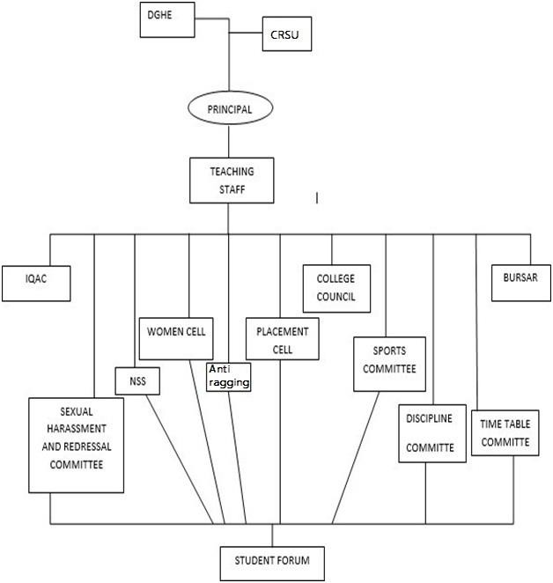**Organogram of the Institution Webpage**